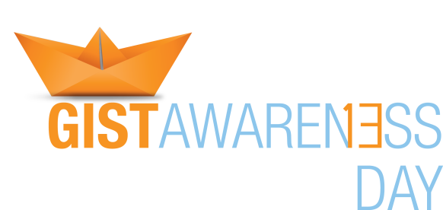

Apply for a GIST Awareness Day Local Event Grant
On Sunday, July 13, 2014 the Life Raft Group will hold the first annual global GIST Awareness Day with three flagship events in the United States: Los Angeles, Chicago and Miami. With these events we hope to raise awareness about GIST and raise funds to continue GIST research. Through educational workshops, social media, webcasts, federal and state level patient advocacy and national media outreach, we will be working hard to raise public awareness about GIST. As an added feature, we, the GIST community, will be attempting to break a Guinness World Record for the largest display of origami boats, a fun activity for all ages. GIST Awareness Day is a worldwide movement….so even if you do not live close enough to one of these cities to attend our events we want to encourage you to host one of your own!!
The LRG is making funding available to local chapters and members to conduct community level GIST Awareness Day events with outreach grants of up to $500. In addition to funding, the LRG will also have other GIST Awareness Day resources available for local event planning and implementation. For example, our GIST Awareness Day Toolkit will have logos, PR templates, sponsorship forms, origami instructions, advocacy tips, educational materials and other information to help create a successful and fun event. We will be also be compiling a video which will be available for viewing at all GIST Awareness Day events. LRG technical support will also be available to grantees.
It’s easy to apply. Just fill out the one page application. Awards will be announced the first week of June with grantees invited to a special Virtual Roundtable Discussion to share their event plans and inspire other awardees. Here’s what you need to know:
Grant Guidelines:
Event Date: Sunday, July 13, 2014 Amount: Up to $500
Who is eligible? : Regional chapters and LRG members worldwide
Types of events: Origami folding parties, barbecues, brunches, fundraisers, educational workshops, pot lucks
Possible Locations: Schools, museums, community centers, homes, restaurants, parks, medical institutions
Application Instructions:
Applicants should submit a brief description of the proposed event and a budget outlining projected expenses. We encourage you to use your creativity in designing and planning your event! Think about how best you can combine a fun and rewarding experience with one that also educates and inspires others.
Event description should include estimated number of attendees, venue, activities and educational opportunities offered. Eligible event expenses include: Food, music, t-shirts, printing, supplies, rental costs, and others considered on a case by case basis.
DEADLINE TO SUBMIT APPLICATIONS IS FRIDAY, June 13, 2014
To submit your application form or for any further questions please contact Assistant Program Director Mildred Menos at mmenos@liferaftgroup.org

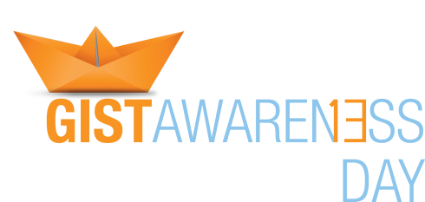

2014 GIST AWARENESS DAY EVENT GRANT APPLICATION

Applicant Information
Full Name: |  |  |  | Grant Request | : $
 | Last | First | M.I.

Address:
 | Street Address | Apartment/Unit #

 | City | State | ZIP Code

Phone: |  | Email

Tell us about yourself:
I am a Life Raft Group Local Group rep? | YES | NO | I am a member of the Life Raft Group? | YES | NO

I am a GIST patient/caregiver? | YES | NO | Other?

Event Description (if needed continue narrative and budget on separate page)
Date & Time:_____________________ | Location: _________________ | Expected Attendance: ______________

Description:

What is the overall goal of your event?

Budget: Please itemize projected expenses
ITEM | AMOUNT ($)
Food
Location Cost
Supplies, T-shirts, Origami paper
Music
Printing
Other (describe):
Other (describe):
Total

Signature: |  | Date:

